Decentralized Traceability and Direct Marketing of Agriculture Supply Chains with QR Scanner

CONTENT
Abstract
1.INTRODUCTION
1.1 Motivation
1.2 Problem Statement
1.3 Objective of the Project
1.4 Scope
1.5 Project Introduction
2.LITERATURE SURVEY
2.1 Related Work
3. SYSTEM ANALYSIS
3.1 Existing System
3.2 Disadvantages
3.3 Proposed System
3.4 Advantages
3.5 work Flow of Proposed system
4. REQUIREMENT ANALYSIS
4.1 Function and non-functional requirements
4.2 Hardware Requirements
4.3 Software Requirements
4.4 Architecture
5. SYSTEM DESIGN
5.1 Introduction of Input design
5.2 UML Diagram(class, use case, sequence, collaborative, deployment, activity, ER diagram and Component diagram)
5.3 Data Flow Diagram
6. IMPLEMENTATION AND RESULTS
6.1 Modules
6.3 Output Screens
- METHODOLOGY
Sha256
- SYSTEM STUDY AND TESTING
8.1 Feasibility study
8.2 Types of test & Test Cases
9. CONCLUSION
10. FUTURE ENHANCEMENT
11. REFERENCES

ABSTRACT:
The decentralized traceability and direct marketing platform for agriculture supply chains. Globalized delivery of manufacturing and agricultural production offer renewed attention to the health, efficiency, and validation of many vital criteria in the food and agricultural supply chain. That numbers of food safety and corruption hazards have generated an enormous need of an efficient traceability solutions which acts as an essential quality managements tools ensuring to enough product’s safety within the agriculture supply chain. Block chain is the revolutionary technological method, which provides the ground breaking result for commodity traceableness in agriculture and in food supply chains. Today's agricultural supplying chains are complicated ecosystems mixing several stakeholders making it difficult to validate several significant requirements mainly towards nation of first origin, crop growth phases, quality standards compliance, and yield monitoring. This paper proposes a strategy that levitates the block chain and conducts business operations effectively across the agricultural supply chain for tracking crop prices and traceability. The proposed framework solution discards the need for trusted centralized authority, intermediaries and offers records of the transactions, improving efficient science and safety with high integrity and reliability. All transactions are registered and then stored in block chain’s unchangeable ledger with linkages to a decentralized le network, thereby ensuring vary high degree of traceability and transparency in the supply chain ecosystem in a stable, reliable and in efficient manner.
Keywords: Decentralized, Traceability, Direct marketing, Agriculture, Supply chains, QR scanner.
- INTRODUCTION
1.1Motivation:
The globalized nature of agricultural supply chains has heightened concerns about food safety, efficiency, and authenticity. Numerous food safety risks and incidents of corruption necessitate robust traceability solutions to ensure product safety. Blockchain, an innovative technology, promises unparalleled traceability in agriculture and food supply chains. Current supply chains, with their complex interactions and multiple stakeholders, face challenges in verifying essential criteria like origin, growth stages, and quality standards. Blockchain eradicates the need for centralized authorities and intermediaries, ensuring efficient, transparent, and reliable traceability, enhancing overall food safety and supply chain integrity.
1.2 Problem Statement:
The globalized nature of agricultural production and manufacturing has intensified concerns regarding food safety, efficiency, and validation within supply chains. The rising incidents of food safety breaches and corruption highlight the dire need for efficient traceability solutions as vital quality management tools. Contemporary agricultural supply chains are intricate, involving multiple stakeholders, making verification of origin, growth phases, and compliance challenging. Existing systems, reliant on centralized authorities and intermediaries, lack transparency and integrity. There's a pressing demand for a decentralized, reliable solution to ensure transparency, traceability, and efficiency in agricultural supply chains.
1.3 object of the project:
The project aims to revolutionize the agricultural supply chain by integrating blockchain technology, enhancing traceability and transparency. This decentralized platform addresses food safety and corruption concerns, ensuring product safety and quality standard compliance. By eliminating the need for centralized authorities and intermediaries, the strategy offers an immutable record of transactions, bolstering efficiency, security, and trustworthiness. It streamlines the complex supply chain ecosystem, ensuring accurate tracking of crop prices, origin, growth stages, and yield monitoring, fostering a reliable and efficient system.
1.4 Scope:
The project aims to revolutionize agricultural supply chains using blockchain technology. By decentralizing traceability and eliminating the need for intermediaries, it ensures high-quality standards, enhanced product safety, and verifiable origin tracking. The proposal leverages blockchain's immutable ledger, recording all transactions and offering unparalleled transparency and reliability. This approach simplifies complex supply ecosystems, making crop price tracking, compliance, and yield monitoring more efficient, ultimately fostering a trustworthy, transparent, and streamlined supply chain environment.
1.5 Project Introduction:
To ensure product safety, handling the growth of farming products and effective management of logistics -chain in agricultural supply chain is censorious. That cover about food safety and the risk of contamination has renewed the prominence of tracing power across the supply chain Moreover, farming goods exchanged across multiple nations require accurate tracking and compliance with nation-specific regulations Tracing of goods in the agricultural field requires to gather, communicate and maintain critical data by specifically identifying the source, multiple data exchanges in the logistic network. High-spirited nature of data in the agricultural / food supply chain where products are manufactured, processed and sent through multiple intermediaries allows tracking and tracing difficult. Contamination of products and its public health consequences highlight traceability as the required policy instrument for tracking food quality and safety. The present traceability practice in the supply chain of agriculture is mainly affected by data fragmentation and centralized controls that are susceptible to both information modification and management. In case of contamination that identifies the source and isolates the product quickly from the supply chain. Today's supply chain is becoming really complex. At various stage multiple stakeholder are present. All these Stakeholder need to collaborate with each other in various direction for efficient and effective management. To deal with food scares and accidents, the food industry becoming more customer-oriented and need quicker response time. Good traceability mechanisms help reduce the manufacture and sale of dangerous or low quality goods, mitigating the risk for false ads, liability and recalls. Reducing the impacts of food safety. Improving food safety, and providing a means to verify food quality attribute are driving the development of traceability initiatives in agri-food system. The United Nation Food and Agriculture Organization (FAO) and the International Telecommunications Union (ITU) are continuing to work together to facilitate the use of innovation Information and communication technologies (ICTs) in agriculture. The importance of traceability has significantly increased with the globalization of the food industries. Therefore, the need for a reliable identification and tracking system is necessary to ensure the quality and safety of food which reaches the consumer. Block chain for Supply Chain is a natural fusion of two technologies, built for mutual or common ledge transactions. A supply chain often reflects a distribution of products through industries, and is also cross-border. Food provenance is one pf FSC’s most difficult issue. This issue companies are facing today. A global supply chain network with asymmetric food regulation and multiple operating procedure between various countries makes end-to-end food tracking incidental to the food industry. Distributed ledger/Block chain is very important technology that can significantly impact the supply chain management. This paper shows the possibility of block chain technology using supply chain for both perishable product and manufacturing. In food supply chain firms are rapidly adopting block chain system. Example for retailers such as Carrefour indicates that block chain can be used to provide access to rich and details information about food product, which is used to reduce the uncertainty about quality and ingredient. Food safety has been an enormous concern in china over the last few years. As conventional agri-food logistic practices can no longer satisfy consumer demands, developing a traceability framework for agri-food supply is becoming increasingly urgent.
- LITERATURE SURVEY
  - Related Work:
[1] M. M. Aung and Y. S. Chang, ‘‘Traceability in a food supply chain: Safety and quality perspectives,’’ Food Control, vol. 39, pp. 172–184, May 2014.
The paper by M. M. Aung and Y. S. Chang, titled 'Traceability in a Food Supply Chain: Safety and Quality Perspectives' (2014), introduces the pivotal concept of traceability within the context of food supply chains. It acknowledges the growing importance of traceability in ensuring food safety and quality, especially in light of foodborne illness outbreaks and increasing consumer concerns. The introduction highlights the need for effective traceability systems to enhance transparency, reduce risks, and bolster consumer confidence in food products.
The proposed method in the paper focuses on implementing traceability systems within the food supply chain. It delves into the key components and processes necessary for effective traceability, such as data collection, tracking, and documentation of critical information at various stages of the supply chain. The authors emphasize the utilization of technologies and standards that enable the traceability of food products from farm to fork, aiming to improve food safety and quality.
In summary, Aung and Chang's paper underscores the vital role of traceability in enhancing food safety and quality. It emphasizes the need for comprehensive systems that facilitate accurate tracking and documentation of food products throughout the supply chain. The study underscores that such traceability systems are essential for preventing and mitigating food safety issues and for building consumer trust. By providing insights into the safety and quality perspectives, the paper contributes to the ongoing discussions on improving food supply chain management.
[2] T. Bosona and G. Gebresenbet, ‘‘Food traceability as an integral part of logistics management in food and agricultural supply chain,’’ Food Control, vol. 33, no. 2, pp. 32–48, 2013.
In their 2013 study, T. Bosona and G. Gebresenbet examine "Food traceability as an integral part of logistics management in food and agricultural supply chain." The introduction sets the stage by emphasizing the growing importance of traceability in ensuring food safety and quality. It recognizes the complexities of modern supply chains and the need for an integrated approach to traceability in the food and agricultural sector.
The proposed method in the study underscores the significance of integrating traceability into logistics management within the food and agricultural supply chain. It outlines key components, such as data collection, information systems, and technology adoption, to achieve seamless traceability. The method suggests that by incorporating traceability as an essential aspect of logistics management, supply chains can improve efficiency, mitigate risks, and enhance the overall quality and safety of food products.
In summary, Bosona and Gebresenbet's research underscores the critical role of food traceability within logistics management for food and agricultural supply chains. They argue that a comprehensive approach to traceability is crucial to meet the demands of a complex and globalized supply chain system. Effective traceability systems not only enhance food safety and quality but also enable supply chain stakeholders to respond more efficiently to issues and recalls. By viewing traceability as integral to logistics, the study highlights the potential for supply chains to become more robust, transparent, and reliable.

[3] J. Hobbs, ‘‘Liability and traceability in agri-food supply chains,’’ in Quantifying the Agri-Food Supply Chain. Springer, 2006, pp. 87–102.
In J. Hobbs' 2006 work, 'Liability and Traceability in Agri-Food Supply Chains,' the introduction sets the stage by addressing the essential concepts of liability and traceability in agri-food supply chains. It emphasizes the growing concern over food safety and quality, highlighting the need for robust systems to trace products and assign responsibility throughout the supply chain.
Hobbs' paper suggests a method for enhancing traceability and managing liability in agri-food supply chains. The proposed method advocates for the implementation of standardized tracking and documentation systems, integrating information and communication technologies. This approach aims to improve transparency and accountability across the supply chain, offering a framework for efficient product tracing and risk management.
In summary, Hobbs' work underscores the significance of traceability and liability in agri-food supply chains, particularly in the context of ensuring food safety and quality. It highlights the potential benefits of improved tracking systems and the allocation of responsibility. The study advocates for the development and adoption of these methods to enhance the integrity and security of the agri-food supply chain.
[4] D. Mao, Z. Hao, F. Wang, and H. Li, ‘‘Novel automatic food trading system using consortium blockchain,’’ Arabian J. Sci. Eng., vol. 44, no. 4, pp. 3439–3455, Apr. 2018.
The 2018 paper by D. Mao, Z. Hao, F. Wang, and H. Li, titled 'Novel Automatic Food Trading System Using Consortium Blockchain,' introduces the concept of an innovative food trading system. It highlights the need for efficient and secure food supply chain management, emphasizing the potential of consortium blockchain technology in achieving this goal. The introduction sets the stage for a novel approach to revolutionizing the food trade sector.
The proposed method in this study outlines the development and implementation of an automatic food trading system based on consortium blockchain technology. It describes how this system streamlines the food supply chain by incorporating various stakeholders, such as farmers, suppliers, and consumers. The blockchain ensures transparency, traceability, and security, enabling participants to engage in trustful transactions. Smart contracts play a pivotal role in automating and optimizing the trading processes, reducing inefficiencies, and enhancing the overall reliability of the food supply chain.
In summary, this research presents an innovative solution to revolutionize the food trading industry. By leveraging consortium blockchain and smart contracts, it creates a secure and efficient ecosystem for all stakeholders. The system enhances transparency, traceability, and trust, addressing critical issues in food supply chain management. It offers promising prospects for automating and optimizing food trade processes, reducing costs, and ensuring the integrity and safety of food products from source to consumption.
[5] L. U. Opara and F. Mazaud, ‘‘Food traceability from field to plate,’’ Outlook Agricult., vol. 30, no. 2, pp. 239–247, 2001.
In their 2001 paper titled "Food Traceability from Field to Plate," L. U. Opara and F. Mazaud set the stage by emphasizing the critical importance of food traceability in the agricultural and food industry. They acknowledge the increasing concerns about food safety, quality, and authenticity among consumers and regulatory bodies. The introduction highlights the growing need for systems that can trace food products from their origin to consumers' plates to address these concerns and enhance the overall integrity of the food supply chain.
Opara and Mazaud's proposed method outlines a comprehensive framework for implementing food traceability. It stresses the necessity of standardized tracking and documentation systems throughout the entire supply chain. The authors discuss the vital components of effective traceability, which encompass data collection from the field, processing, distribution, and retail stages. Their approach integrates technologies and information systems to capture and record essential data points such as batch numbers, production dates, and the origin of products. This allows for the seamless flow of information from the field to the final consumer, ensuring transparency and accountability at every stage of the supply chain.
In summary, Opara and Mazaud's research underscores the significance of food traceability as a fundamental solution to enhance food safety and quality. Their proposed method showcases the role of advanced technologies in streamlining data collection and sharing, which can substantially reduce the risks associated with foodborne illnesses, while also bolstering consumer confidence. By emphasizing traceability and accountability, their approach contributes to more efficient supply chain management, offering benefits for both producers and consumers, ultimately supporting safer and higher-quality food products.
3. SYSTEM ANALYSIS
3.1 Existing System
There is no computerized system in place to trace the cost of agriculture. Agricultural products cannot be obtained by the farmer.72 percent of the population in India is dependent on the farming industry. Farmers get enormous quantities of crop manufacturing, but they have not got the correct price because they can survive the present circumstances. So they are suicide and nothing is done by the government. So we are attempting to fix this issue in the suggested scheme by tracing the cost of the agricultural product from farmer to client.
3.2 Disadvantages
- Complexity in Implementation: Setting up decentralized systems can be intricate, demanding expertise and resources, making it challenging for smaller agricultural players.
- Interoperability Issues: Ensuring compatibility among various decentralized platforms and technologies can be a hurdle, potentially leading to data silos and inefficiencies.
- Scalability Constraints: Expanding a decentralized system to accommodate a growing number of users and transactions can be challenging, causing performance issues.
- Security Risks: Decentralized systems are not immune to security threats like smart contract vulnerabilities and hacking, posing risks to data integrity and user trust.
3.3 Proposed System
In proposed system we are using a Block chain helps which helps in maintaining the integrity and transparency of the whole process right from inception of crop details. Blockchain helps in managing and tracing the crop information transparent distribution.
3.4 Advantages
- Enhanced Transparency: Decentralized traceability allows consumers to track the journey of agricultural products from farm to table, fostering trust.
- Reduced Fraud: Direct marketing eliminates intermediaries, reducing the risk of counterfeit goods and fraud in the supply chain.
- Fair Pricing: Farmers receive a fair share of profits by selling directly to buyers, avoiding price manipulation by middlemen.
- Efficient Logistics: Real-time data improves inventory management and logistics, reducing wastage and optimizing distribution.

3.5 work Flow of Proposed system
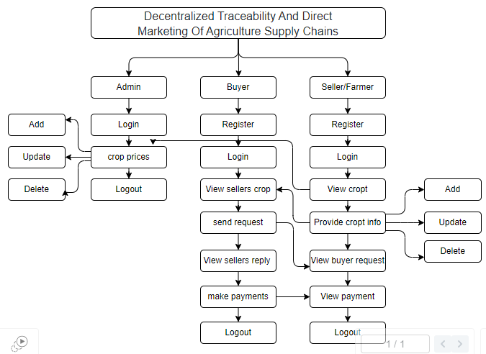
4. REQUIREMENT ANALYSIS
4.1 Functional and non-functional requirements
Requirement’s analysis is very critical process that enables the success of a system or software project to be assessed. Requirements are generally split into two types: Functional and non-functional requirements.
Functional Requirements: These are the requirements that the end user specifically demands as basic facilities that the system should offer. All these functionalities need to be necessarily incorporated into the system as a part of the contract. These are represented or stated in the form of input to be given to the system, the operation performed and the output expected. They are basically the requirements stated by the user which one can see directly in the final product, unlike the non-functional requirements.
Examples of functional requirements:
- Authentication of user whenever he/she logs into the system
- System shutdown in case of a cyber-attack
- A verification email is sent to user whenever he/she register for the first time on some software system.
Non-functional requirements: These are basically the quality constraints that the system must satisfy according to the project contract. The priority or extent to which these factors are implemented varies from one project to other. They are also called non-behavioural requirements.
They basically deal with issues like:
- Portability
- Security
- Maintainability
- Reliability
- Scalability
- Performance
- Reusability
- Flexibility
Examples of non-functional requirements:
- Emails should be sent with a latency of no greater than 12 hours from such an activity.
- The processing of each request should be done within 10 seconds
- The site should load in 3 seconds whenever of simultaneous users are > 10000

  - Hardware Requirements

Processor - I3/Intel Processor
Hard Disk - 160GB
Key Board - Standard Windows Keyboard
Mouse - Two or Three Button Mouse
Monitor - SVGA
RAM - 8GB

  - Software Requirements:
Operating System : Windows 7/8/10
Server side Script : HTML, CSS, Bootstrap & JS
Programming Language : Python
Libraries : Flask, Pandas, Mysql.connector, Os, Smtplib, Numpy
Web3, truffle, Ganache
IDE/Workbench : PyCharm
Technology : Python 3.6+
Server Deployment : Xampp Server
Database : MySQL

  - Architecture:
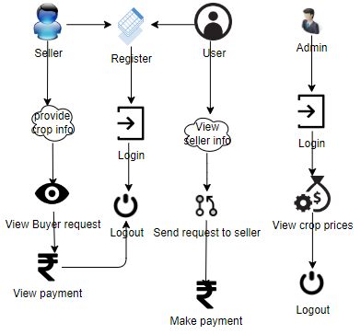

5. SYSTEM DESIGN
5.1 Introduction of Input Design:
In an information system, input is the raw data that is processed to produce output. During the input design, the developers must consider the input devices such as PC, MICR, OMR, etc.
Therefore, the quality of system input determines the quality of system output. Well-designed input forms and screens have following properties −
- It should serve specific purpose effectively such as storing, recording, and retrieving the information.
- It ensures proper completion with accuracy.
- It should be easy to fill and straightforward.
- It should focus on user’s attention, consistency, and simplicity.
- All these objectives are obtained using the knowledge of basic design principles regarding −
  - What are the inputs needed for the system?
  - How end users respond to different elements of forms and screens.

Objectives for Input Design:
The objectives of input design are −
- To design data entry and input procedures
- To reduce input volume
- To design source documents for data capture or devise other data capture methods
- To design input data records, data entry screens, user interface screens, etc.
- To use validation checks and develop effective input controls.

Output Design:
The design of output is the most important task of any system. During output design, developers identify the type of outputs needed, and consider the necessary output controls and prototype report layouts.

Objectives of Output Design:
The objectives of input design are:
To develop output design that serves the intended purpose and eliminates the production of unwanted output.
To develop the output design that meets the end user’s requirements.
To deliver the appropriate quantity of output.
To form the output in appropriate format and direct it to the right person.
To make the output available on time for making good decisions.
5.2 UML Diagrams:
5.2.1 Use Case Diagram:
A use case diagram in the Unified Modeling Language (UML) is a type of behavioral diagram defined by and created from a Use-case analysis. Its purpose is to present a graphical overview of the functionality provided by a system in terms of actors, their goals (represented as use cases), and any dependencies between those use cases. The main purpose of a use case diagram is to show what system functions are performed for which actor. Roles of the actors in the system can be depicted.
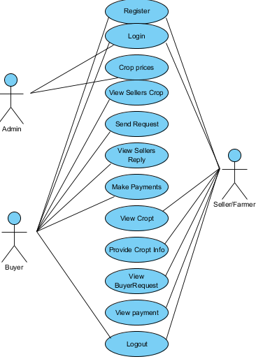
5.2.2 Class Diagram:
In software engineering, a class diagram in the Unified Modelling Language (UML) is a type of static structure diagram that describes the structure of a system by showing the system's classes, their attributes, operations (or methods), and the relationships among the classes. It explains which class contains information.
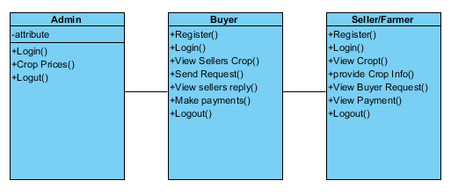
5.2.3 Sequence Diagram:
A sequence diagram in Unified Modelling Language (UML) is a kind of interaction diagram that shows how processes operate with one another and in what order. It is a construct of a Message Sequence Chart. Sequence diagrams are sometimes called event diagrams, event scenarios, and timing diagrams.
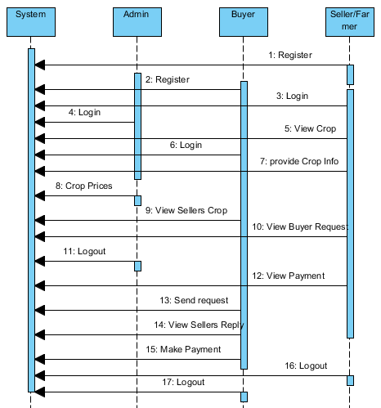
5.2.4 Collaboration Diagram:
In collaboration diagram the method call sequence is indicated by some numbering technique as shown below. The number indicates how the methods are called one after another. We have taken the same order management system to describe the collaboration diagram. The method calls are similar to that of a sequence diagram. But the difference is that the sequence diagram does not describe the object organization whereas the collaboration diagram shows the object organization.
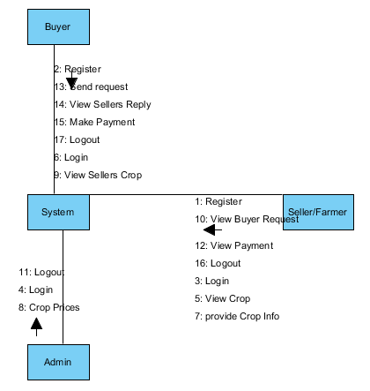
5.2.5 Deployment Diagram
Deployment diagram represents the deployment view of a system. It is related to the component diagram. Because the components are deployed using the deployment diagrams. A deployment diagram consists of nodes. Nodes are nothing but physical hardware’s used to deploy the application.
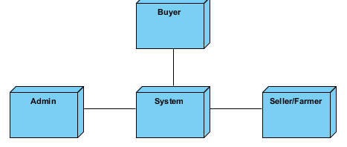
5.2.6 Activity Diagram:
Activity diagrams are graphical representations of workflows of stepwise activities and actions with support for choice, iteration and concurrency. In the Unified Modelling Language, activity diagrams can be used to describe the business and operational step-by-step workflows of components in a system. An activity diagram shows the overall flow of control.
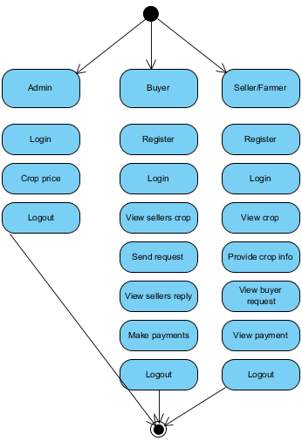

5.2.7 Component Diagram:
A component diagram, also known as a UML component diagram, describes the organization and wiring of the physical components in a system. Component diagrams are often drawn to help model implementation details and double-check that every aspect of the system's required functions is covered by planned development.
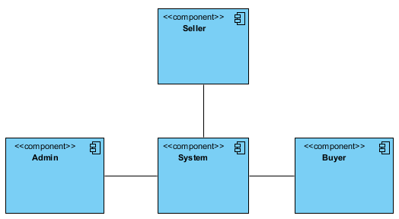
5.2.8 ER Diagram:
An Entity–relationship model (ER model) describes the structure of a database with the help of a diagram, which is known as Entity Relationship Diagram (ER Diagram). An ER model is a design or blueprint of a database that can later be implemented as a database. The main components of E-R model are: entity set and relationship set.
An ER diagram shows the relationship among entity sets. An entity set is a group of similar entities and these entities can have attributes. In terms of DBMS, an entity is a table or attribute of a table in database, so by showing relationship among tables and their attributes, ER diagram shows the complete logical structure of a database. Let’s have a look at a simple ER diagram to understand this concept.
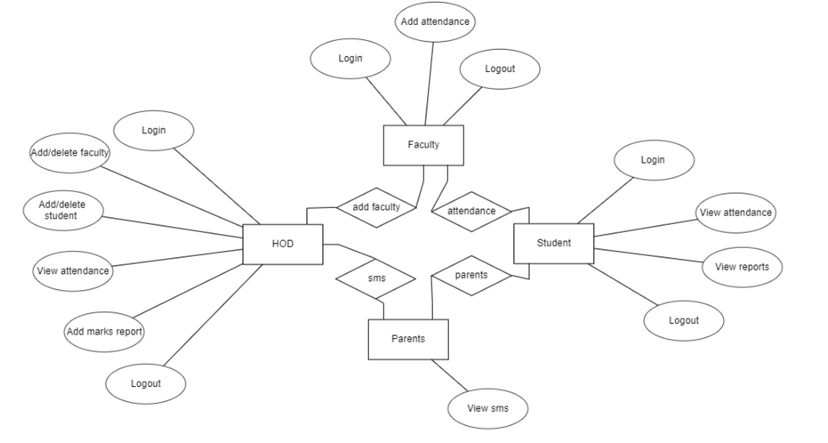
5.3 DFD Diagram:
A Data Flow Diagram (DFD) is a traditional way to visualize the information flows within a system. A neat and clear DFD can depict a good amount of the system requirements graphically. It can be manual, automated, or a combination of both. It shows how information enters and leaves the system, what changes the information and where information is stored. The purpose of a DFD is to show the scope and boundaries of a system as a whole. It may be used as a communications tool between a systems analyst and any person who plays a part in the system that acts as the starting point for redesigning a system.
Level 1 Diagram:
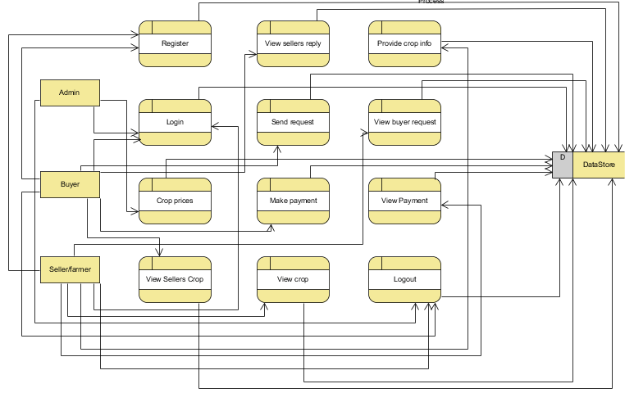

- Level 2 Diagram:
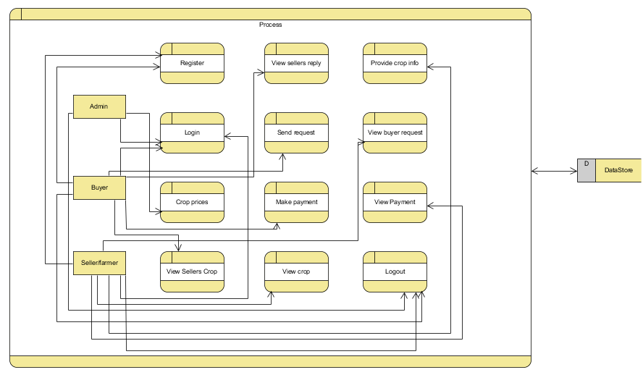
6. MODULES/IMPLEMENTATION
6.1 MODULES:
To develop a decentralized traceability for agriculture supply chains, you can break down the functionality into several modules for the different user roles: Buyer, Seller, and Admin. Here are the modules for each role:
Admin:
- Login: The admin will login with default email and password.
- Crop price: The admin is the person he/ she will add the crop price for each and every crop details with that crop name, category, maximum cost, minimum cost and quantity.
- Logout: Allows the admin to log out securely.
Buyer:
- Register: The buyer will register with their details like name, email, password, address, contact, so after that the buyer will login.
- Login: After registration the buyer will login with their details.
- View Seller's Crop Information: Once the sellers will add the details the buyer can view those details here.
- Send Request to Seller: If the buyer wants the details of crop then buyer will send request to seller.
- View Seller Requests: Displays responses from sellers to the buyer's requests.
- Make Payment: Once the seller accept the request for the crop the buyer has to pay the amount for that crop.
- Logout: Allows buyers to logout securely.
Seller:
- Register: The seller will register with their details like name, email, password, address, contact, so after that the seller will login.
- Login: After registration the seller will login with their details.
- Provide Crop Information: The seller will add there crop details like (crop name, crop category, and quantity and quality).
- View Buyer Requests: When the buyer will send the request for the crop, here the buyer will view and he/she has to accept the request.
- View Payments: Once the buyer will pay the amount for the crops. The seller can view the details of the payment.
- Logout: Allows sellers to logout securely.

Result:
Home Page: Decentralized Traceability and Direct Marketing of Agriculture Supply Chains home page.
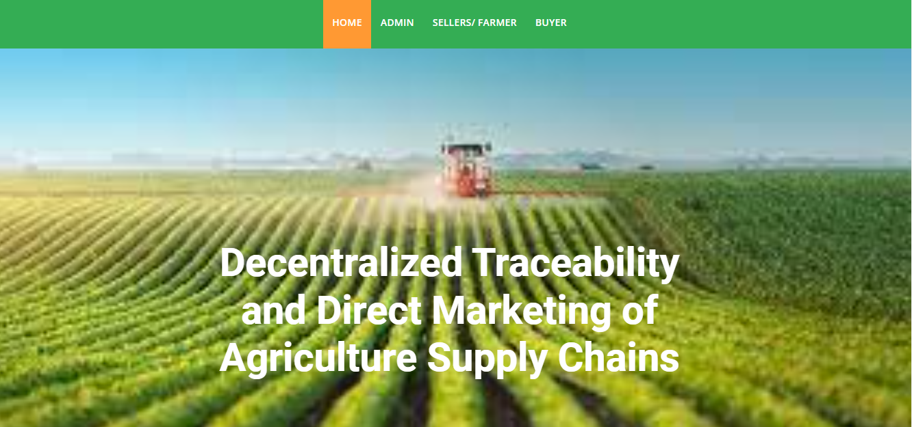
Admin Login page: The admin will login with default email and password.
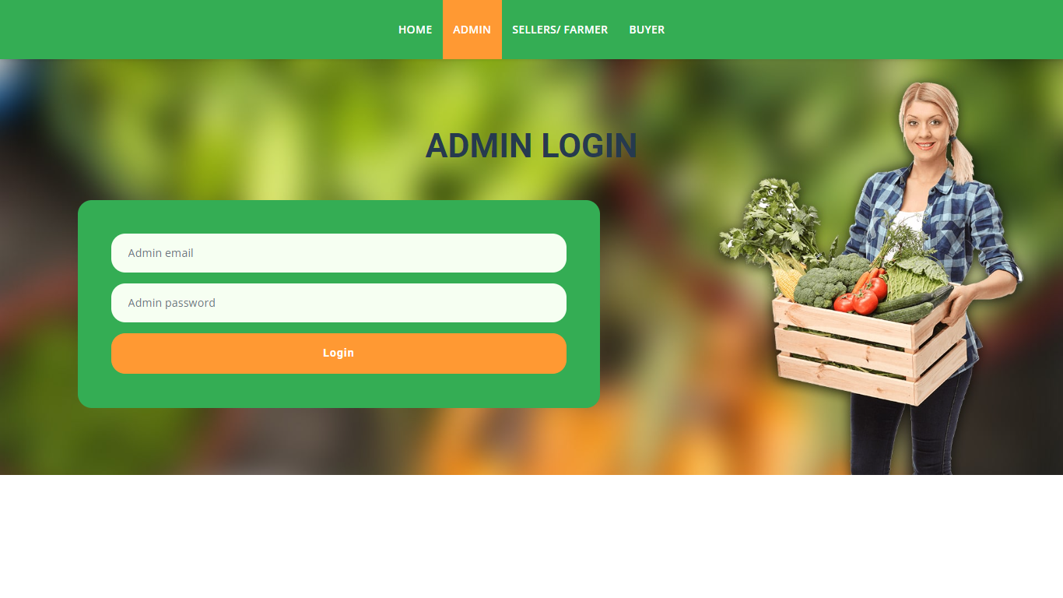

Admin home page: After login the admin will enter into home page.

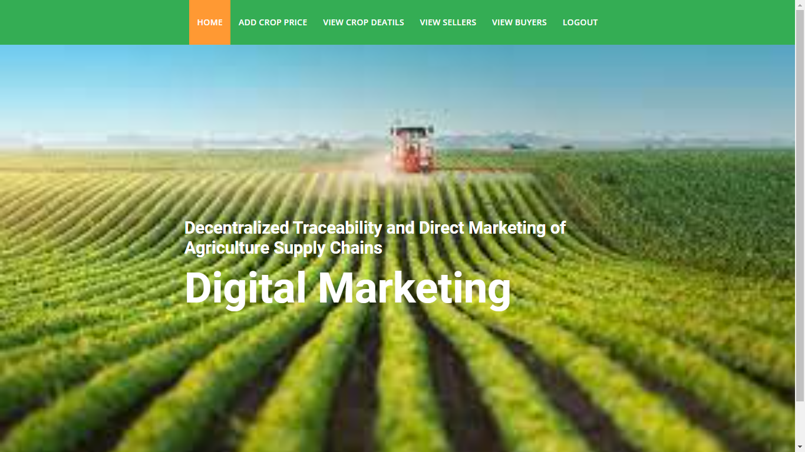
Add crop price: Here the admin can add the crop details, categories, and cost need to enter here.
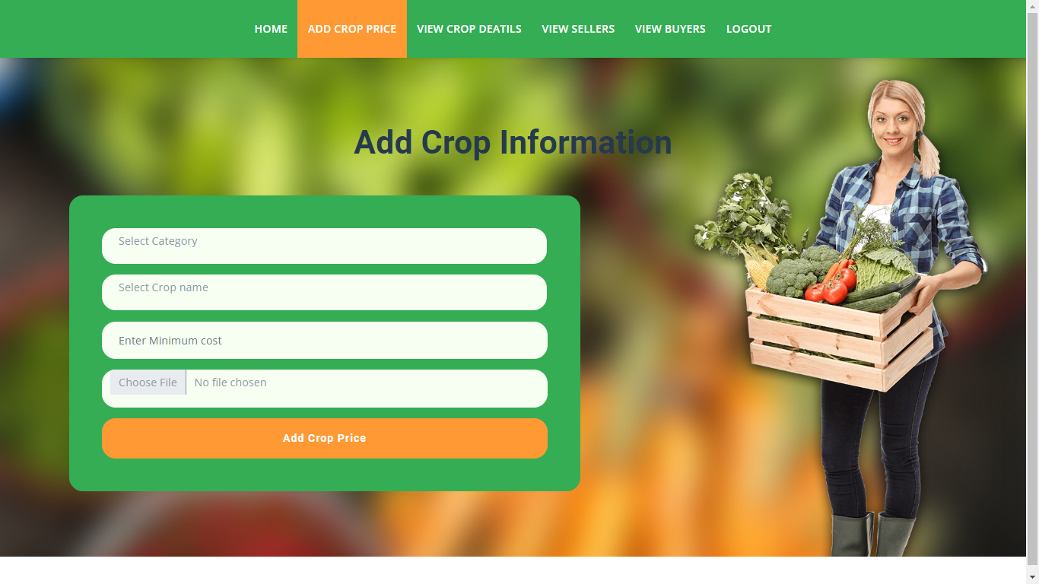

View crop details: Once the sellers/farmers will add the crop details then the admin can view those details.
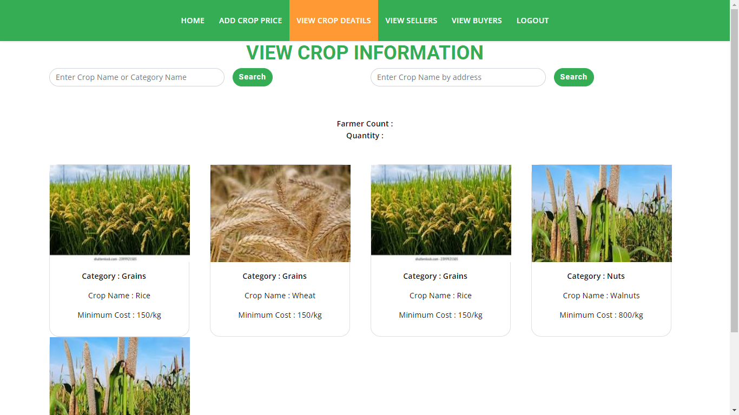

View sellers: Admin can view all the sellers’ details after their registration.

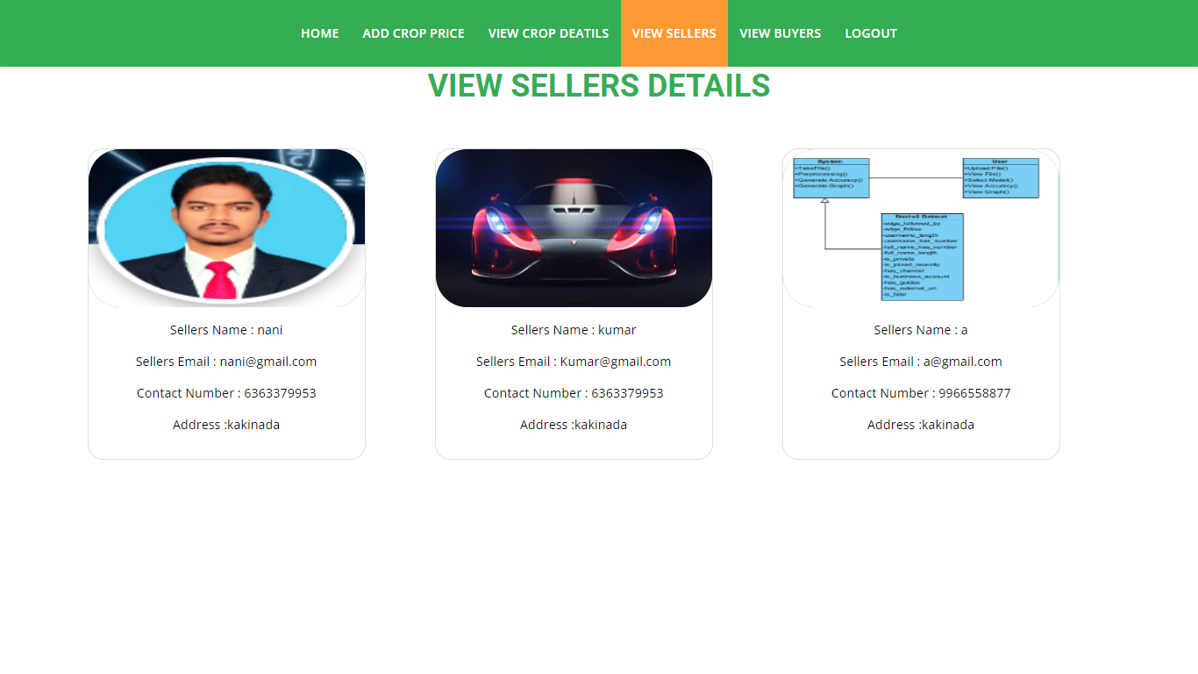

View buyers: Admin can view all the buyers’ details after their registration.

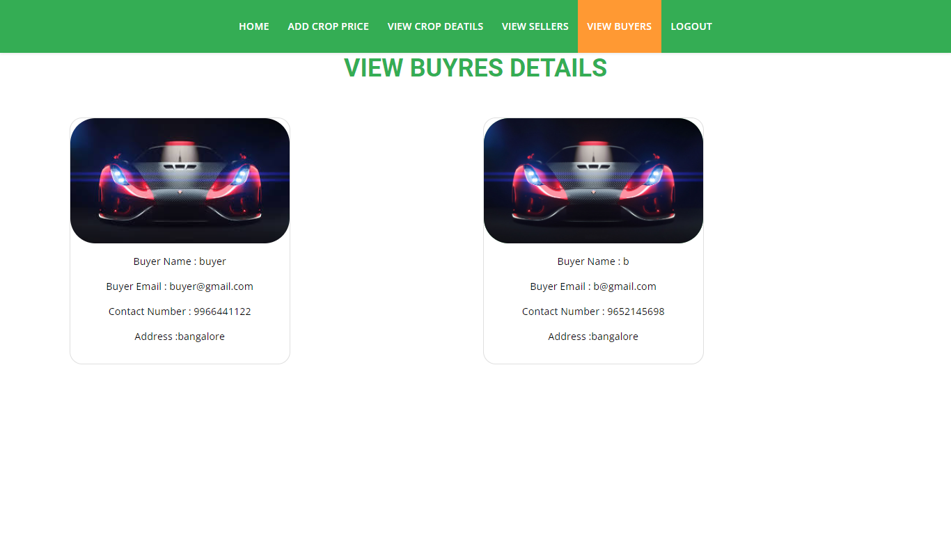
Seller’s registration page: The seller will register with their details like name, email, password, address, contact, so after that the seller will login.

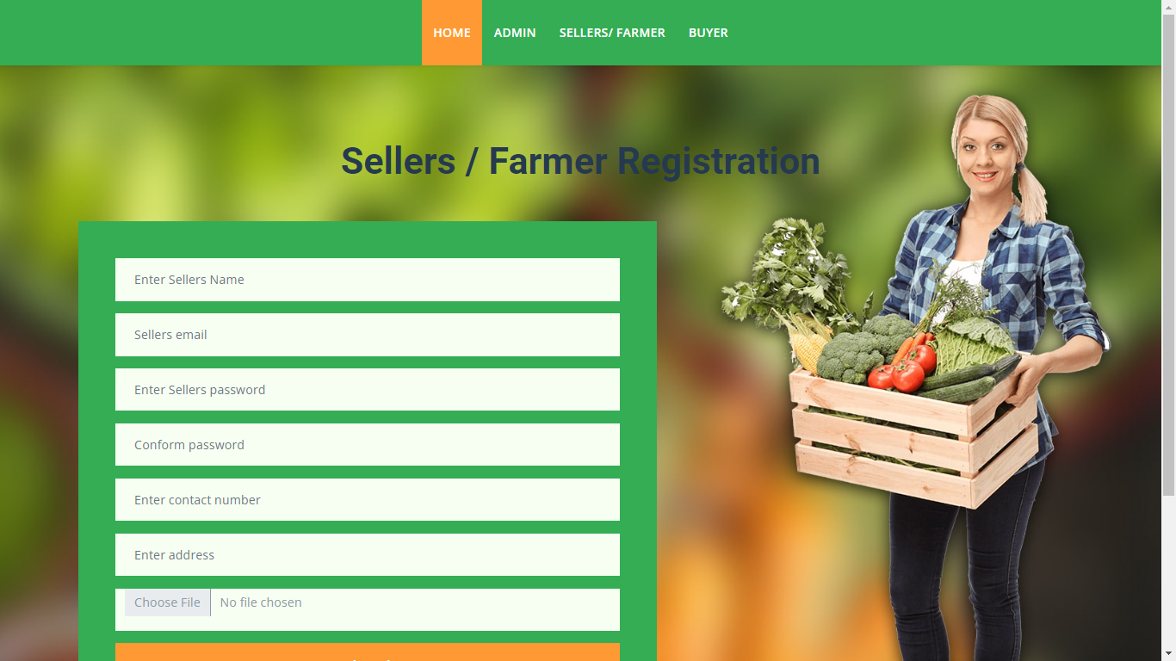

Seller’s login page: After registration the seller will login with their details.

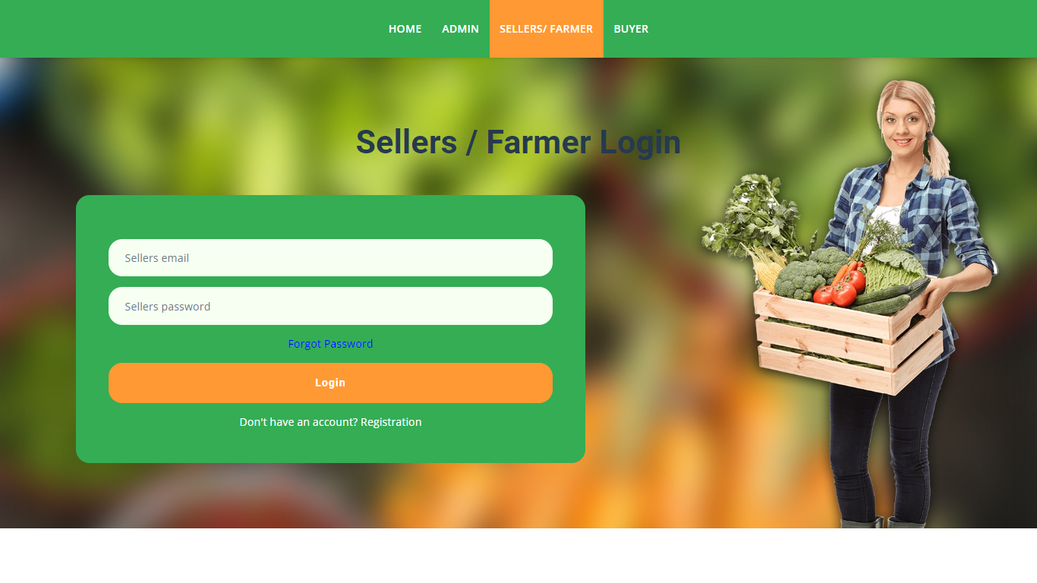
Sellers home page: After Login the will enter into home page.

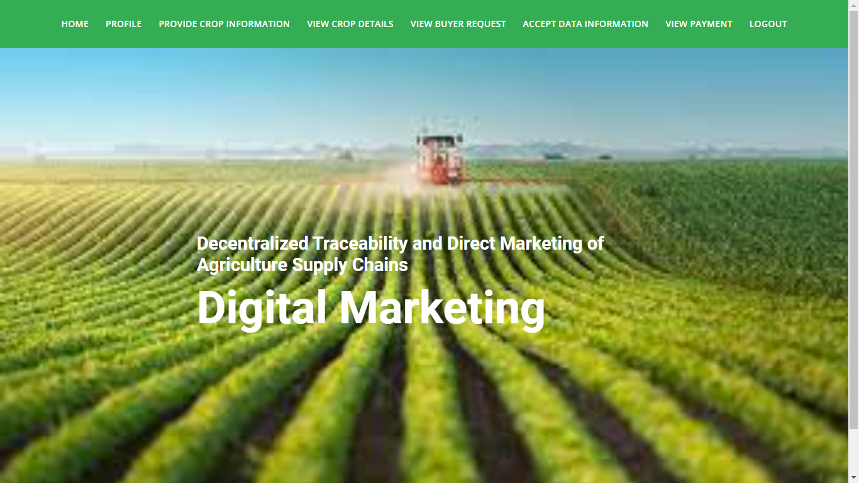

View profile: Here the seller can view the profile.

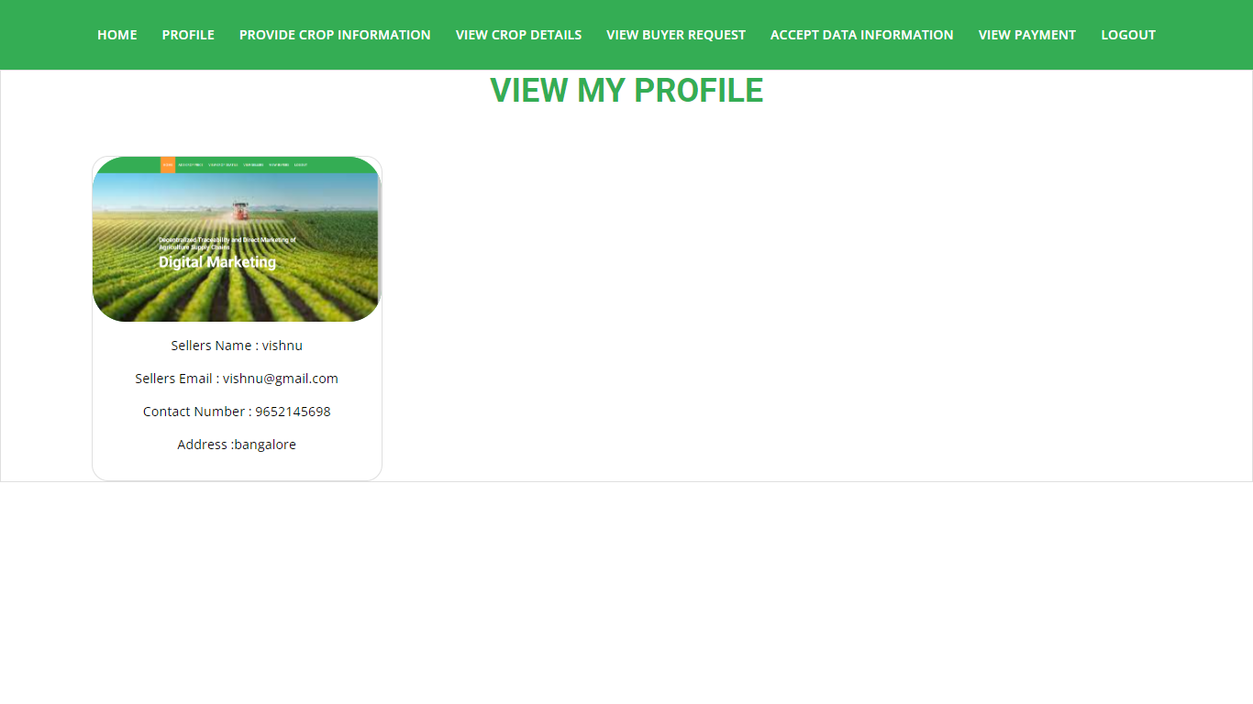

View crop details: Sellers will view the details of the crop and they need to update details.

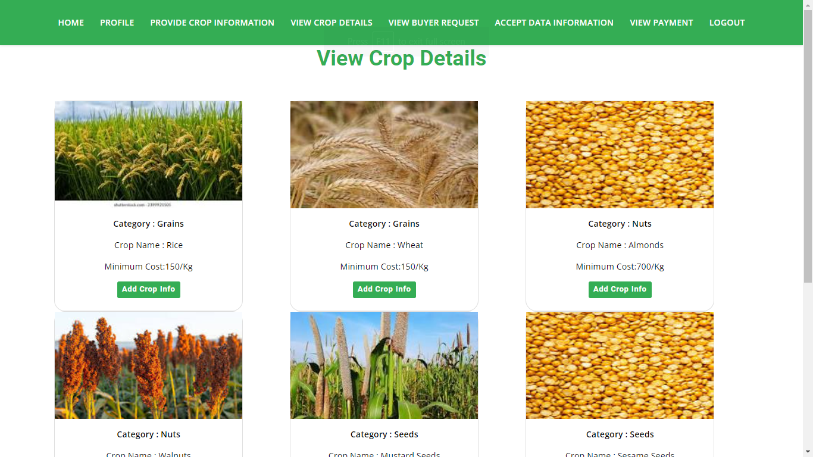

Update crop details: Here the sellers are going to add how much quantity of crop they will grow and when yield will come.

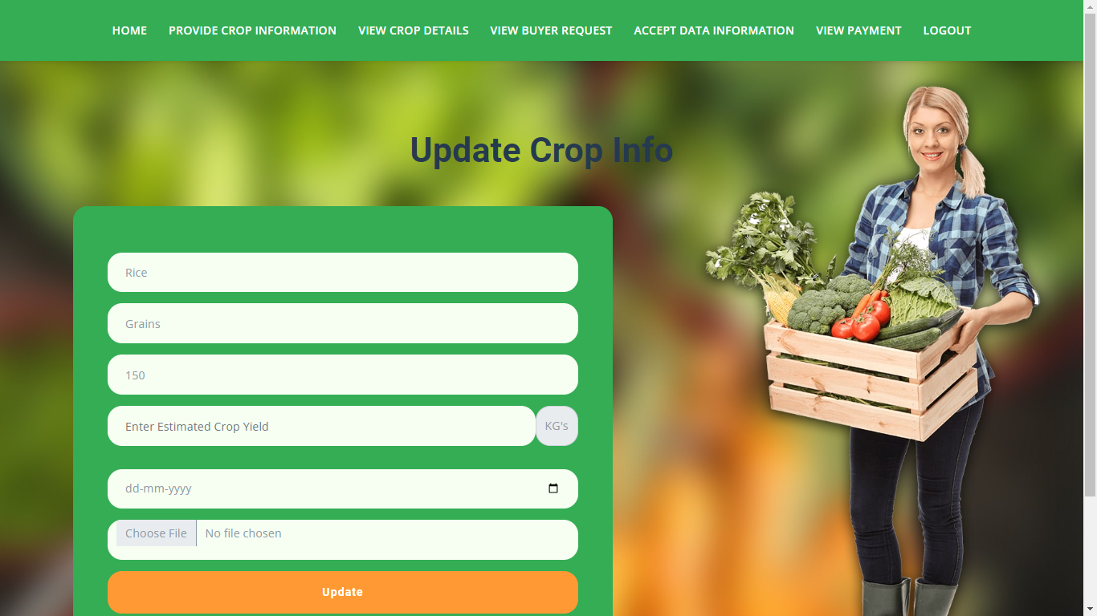

View crop price details: After adding details we can see here with QR code.

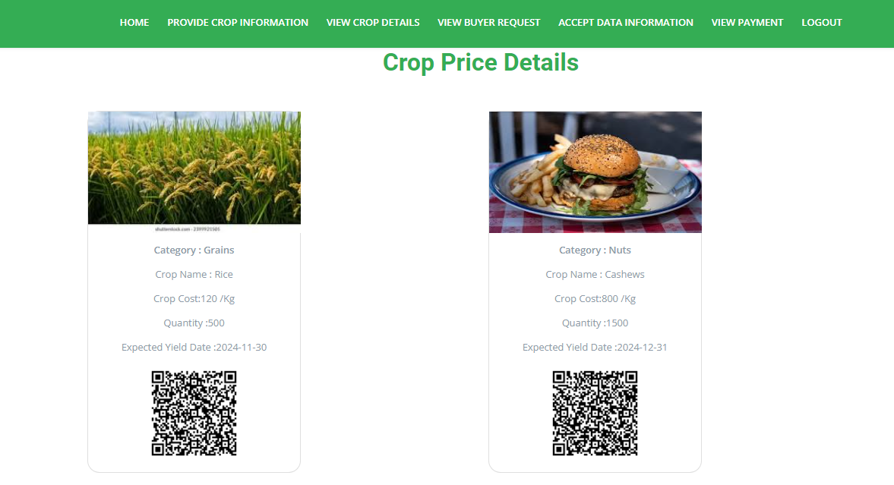

View buyer request: When buyer will request for the crop here sellers need to accept or reject for their crop

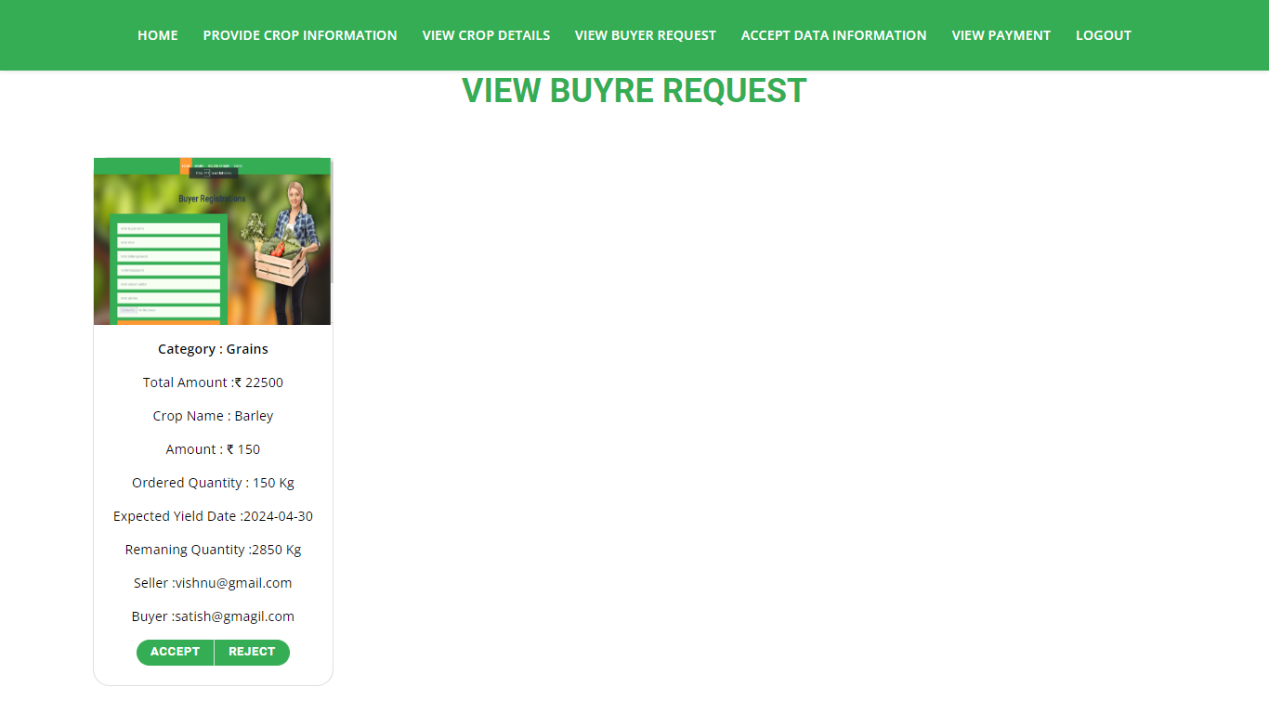

View payment: When the buyer will pay the amount for the crop the sellers will view the data.

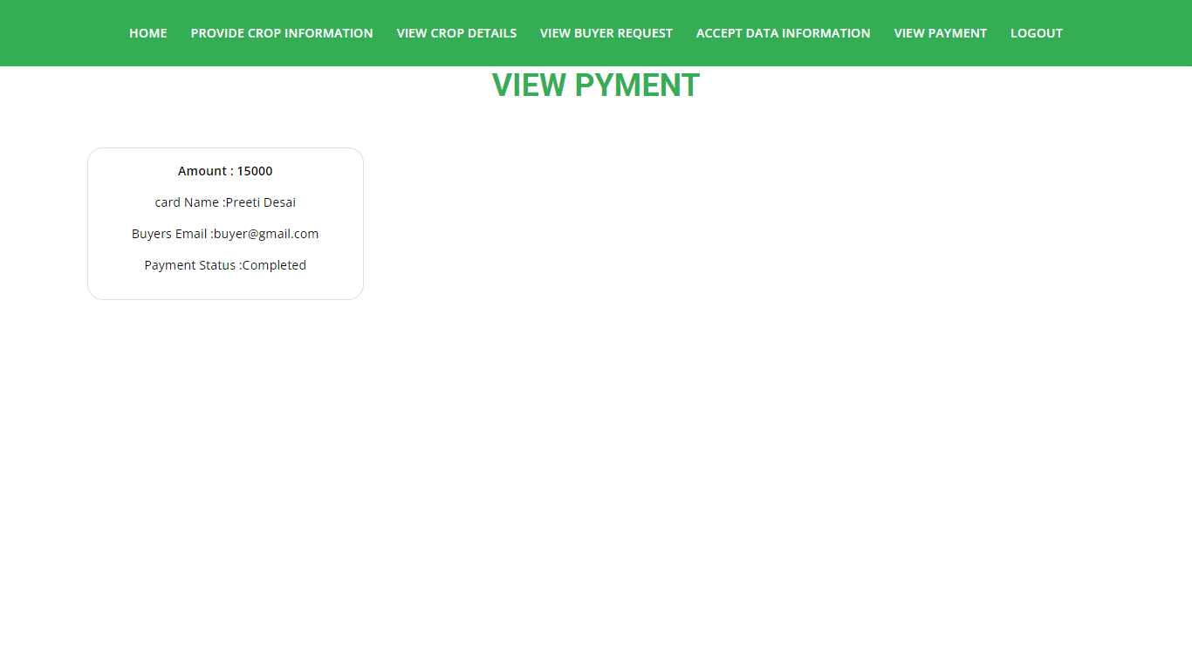

View crop details: Here the buyer can only view the QR code for the crop when they will scan and they can buy

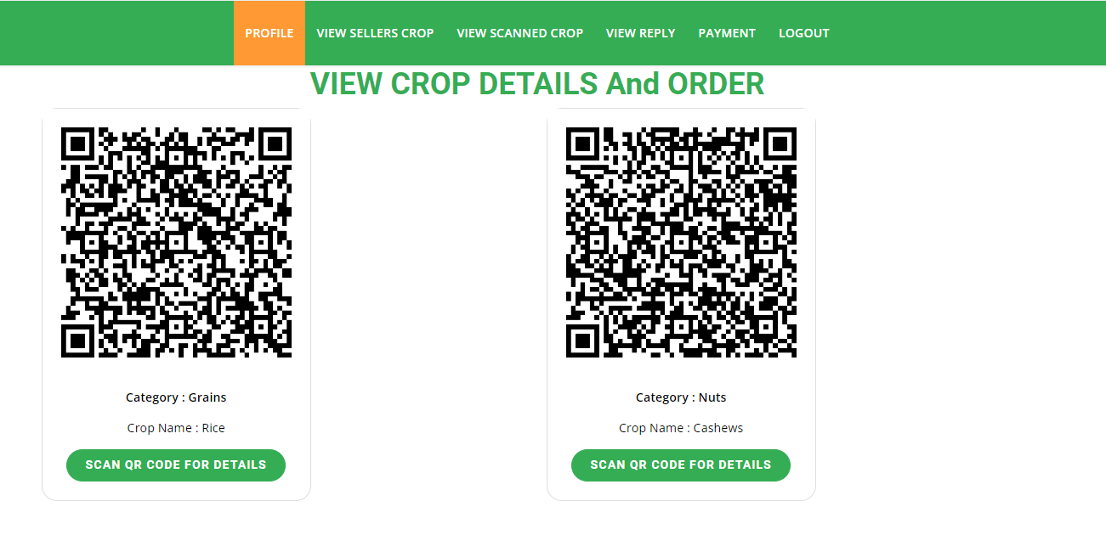

View Scanned Crop Details: After scan only the buyers can view this details and they need to send request for the crop how much he/she need of particular crop.

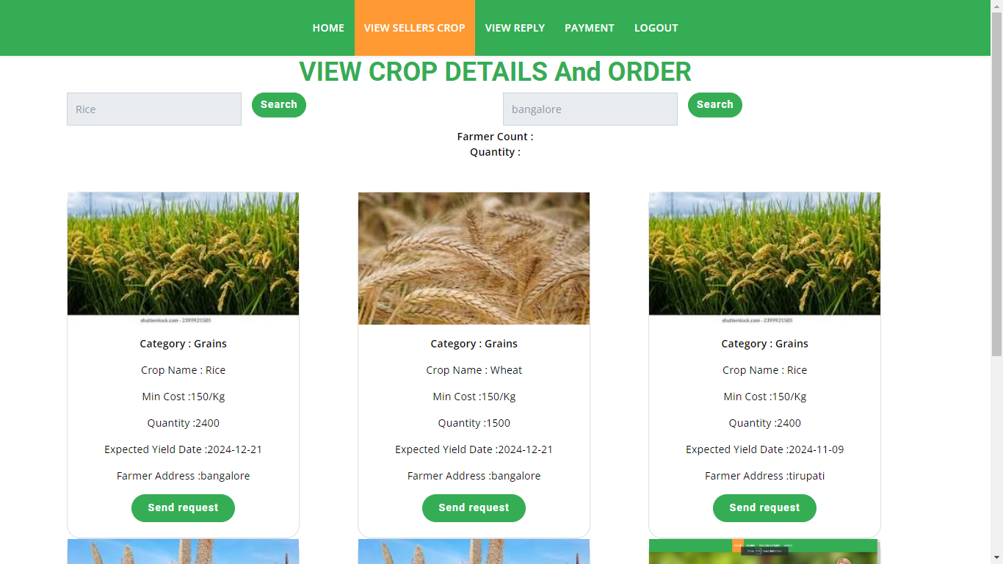

View reply: Here the buyers can view the response for the sellers. After accepting they need to pay the amount after scanning the QR code.
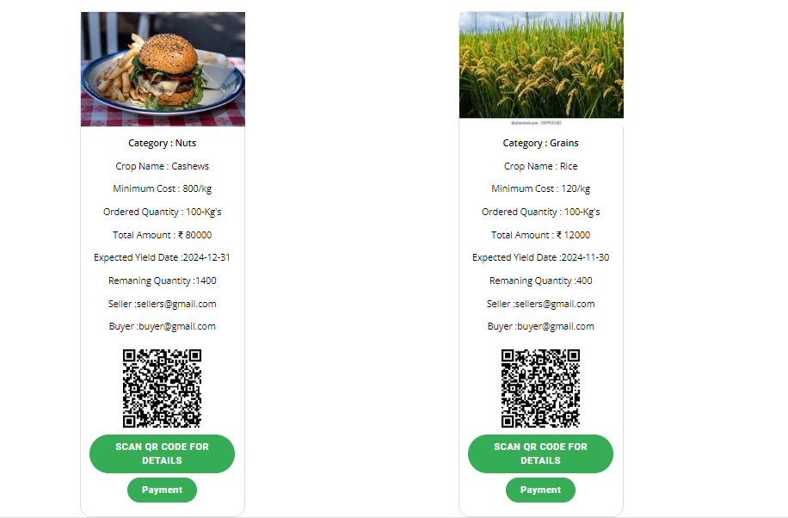

Payment: After scan the QR code Buyer will pay amount, by giving the details like account details.
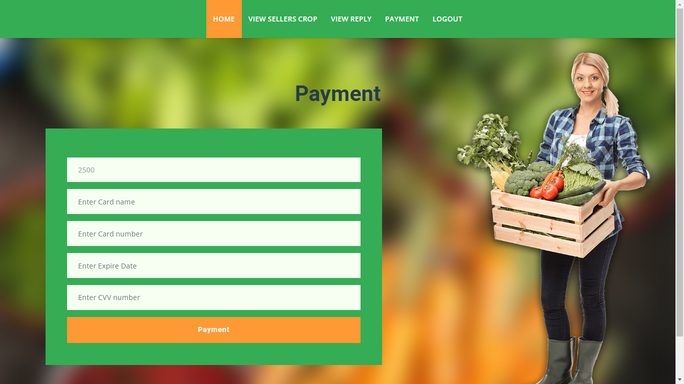

7. Methodology
SHA-256 (Secure Hash Algorithm 256-bit
The SHA-256 (Secure Hash Algorithm 256-bit) is one of the most popular cryptographic hash functions and is one of the variants in the SHA-2 (Secure Hash Algorithm 2) family. Cryptographic hash functions take an input (or "message") and produce a fixed-size string of bytes, typically in the form of a digest that appears random. The output, or hash value, should be the same length regardless of the length of the input.
The "256" in SHA-256 refers to the length of the hash output (digest), which is 256 bits or 32 bytes.
Here are some essential features of cryptographic hash functions like SHA-256:
- Deterministic: The same input will always produce the same output hash.
- Fast to compute: It should be computationally easy to calculate the hash value for any given input.
- Infeasible to generate the original input value: Given a hash output, it should be computationally infeasible to regenerate the original input value.
- Small changes in input produce big changes in output**: Even a tiny change in the input should produce such a drastic change in output that the new hash appears uncorrelated with the old hash.
- No Collision: It should be extremely unlikely that two different inputs could produce the same output hash.
How SHA-256 Works
SHA-256 operates on 512-bit blocks of data and utilizes a variety of bitwise operations including AND, OR, XOR, NOT, bit shifts, and additions (mod 2^32). The algorithm undergoes 64 rounds and utilizes a set of 64 constant 32-bit words, \(K[0], K[1], \ldots, K[63]\), which are derived from the fractional parts of the cube roots of the first 64 prime numbers.
Here's a simplified overview of the algorithm:
- Preprocessing (Padding):
  - Append a single '1' bit to the input.
  - Append '0' bits until the length of the input is congruent to 448 mod 512.
  - Append a 64-bit integer representing the original length of the input (before the padding) as a binary number.
- Initialize Hash Constants:
  - Initialize the 8 hash values (\(H_0\), \(H_1\), ..., \(H_7\)) with initial values that are specific constants provided in the SHA-256 specification. These are derived from the fractional parts of the square roots of the first 8 prime numbers.
- Processing Blocks:
  - Divide the padded message into 512-bit blocks.
  - For each block, perform the following steps:
  - Divide the block into sixteen 32-bit words (\ (W [0], W[1], \ldots, W[15]\)).
  - Extend the sixteen 32-bit words into sixty-four 32-bit words using bitwise operations and additions (mod 2^32).
  - Initialize the 8 working variables \ (a, b, c, \ldots, h \) with the 8 hash values from the last processed block (or the initial hash values for the first block).
  - Perform 64 rounds of computation which update the working variables using bitwise operations and the 64 constant words \ (K[0], K[1], \ldots, K[63]\).
  - Update the hash values (\(H_0\), \(H_1\), ..., \(H_7\)) using the working variables \(a, b, c, \ldots, h\).
- Output:
  - The final hash value is the concatenation of the final \(H_0\), \(H_1\), ..., \(H_7\).
The detailed bitwise operations can get complex but are well-defined in the standard.
The output is a 256-bit hash that serves as a digital fingerprint of the original input data. Note that while it's computationally infeasible to generate the original input value when given the hash output, the hash output uniquely identifies the input data.
7. SYSTEM STUDY AND TESTING
7.1 Feasibility Study
The feasibility of the project is analysed in this phase and business proposal is put forth with a very general plan for the project and some cost estimates. During system analysis the feasibility study of the proposed system is to be carried out. This is to ensure that the proposed system is not a burden to the company. For feasibility analysis, some understanding of the major requirements for the system is essential.
Three key considerations involved in the feasibility analysis are
- Economical feasibility
- Technical feasibility
- Social feasibility
Economical Feasibility
This study is carried out to check the economic impact that the system will have on the organization. The amount of fund that the company can pour into the research and development of the system is limited. The expenditures must be justified. Thus the developed system as well within the budget and this was achieved because most of the technologies used are freely available. Only the customized products had to be purchased.

Technical Feasibility
This study is carried out to check the technical feasibility, that is, the technical requirements of the system. Any system developed must not have a high demand on the available technical resources. This will lead to high demands on the available technical resources. This will lead to high demands being placed on the client. The developed system must have a modest requirement, as only minimal or null changes are required for implementing this system.
Social Feasibility
The aspect of study is to check the level of acceptance of the system by the user. This includes the process of training the user to use the system efficiently. The user must not feel threatened by the system, instead must accept it as a necessity. The level of acceptance by the users solely depends on the methods that are employed to educate the user about the system and to make him familiar with it. His level of confidence must be raised so that he is also able to make some constructive criticism, which is welcomed, as he is the final user of the system.

System Testing
The purpose of testing is to discover errors. Testing is the process of trying to discover every conceivable fault or weakness in a work product. It provides a way to check the functionality of components, sub-assemblies, assemblies and/or a finished product It is the process of exercising software with the intent of ensuring that the
Software system meets its requirements and user expectations and does not fail in an unacceptable manner. There are various types of test. Each test type addresses a specific testing requirement.

7.2 Types of Tests

7.2.1 Unit testing
Unit testing involves the design of test cases that validate that the internal program logic is functioning properly, and that program inputs produce valid outputs. All decision branches and internal code flow should be validated. It is the testing of individual software units of the application .it is done after the completion of an individual unit before integration. This is a structural testing, that relies on knowledge of its construction and is invasive. Unit tests perform basic tests at component level and test a specific business process, application, and/or system configuration. Unit tests ensure that each unique path of a business process performs accurately to the documented specifications and contains clearly defined inputs and expected results.

7.2.2 Integration testing
Integration tests are designed to test integrated software components to determine if they actually run as one program. Testing is event driven and is more concerned with the basic outcome of screens or fields. Integration tests demonstrate that although the components were individually satisfaction, as shown by successfully unit testing, the combination of components is correct and consistent. Integration testing is specifically aimed at exposing the problems that arise from the combination of components.
Software integration testing is the incremental integration testing of two or more integrated software components on a single platform to produce failures caused by interface defects.
The task of the integration test is to check that components or software applications, e.g. components in a software system or – one step up – software applications at the company level – interact without error.
Test Results: All the test cases mentioned above passed successfully. No defects encountered.

Acceptance Testing
User Acceptance Testing is a critical phase of any project and requires significant participation by the end user. It also ensures that the system meets the functional requirements.
Test Results: All the test cases mentioned above passed successfully. No defects encountered.

7.2.3 Functional testing
Functional tests provide systematic demonstrations that functions tested are available as specified by the business and technical requirements, system documentation, and user manuals.
Functional testing is centered on the following items:
Valid Input : identified classes of valid input must be accepted.
Invalid Input : identified classes of invalid input must be rejected.
Functions : identified functions must be exercised.
Output : identified classes of application outputs must be exercised.
Systems/Procedures: interfacing systems or procedures must be invoked.
Organization and preparation of functional tests is focused on requirements, key functions, or special test cases. In addition, systematic coverage pertaining to identify Business process flows; data fields, predefined processes, and successive processes must be considered for testing. Before functional testing is complete, additional tests are identified and the effective value of current tests is determined.

7.2.4 White Box Testing
White Box Testing is a testing in which in which the software tester has knowledge of the inner workings, structure and language of the software, or at least its purpose. It is purpose. It is used to test areas that cannot be reached from a black box level.

7.2.5 Black Box Testing
Black Box Testing is testing the software without any knowledge of the inner workings, structure or language of the module being tested. Black box tests, as most other kinds of tests, must be written from a definitive source document, such as specification or requirements document, such as specification or requirements document. It is a testing in which the software under test is treated, as a black box .you cannot “see” into it. The test provides inputs and responds to outputs without considering how the software works.
Test objectives
- All field entries must work properly.
- Pages must be activated from the identified link.
- The entry screen, messages and responses must not be delayed.
Features to be tested
- Verify that the entries are of the correct format
- No duplicate entries should be allowed
- All links should take the user to the correct page.

- TEST CASES:
Input | Output | Result
Input image | Decentralized traceability and direct marketing of agriculture supply chains | Success

- Test cases Model building:
S.NO | Test cases | I/O | Expected O/T | Actual O/T | P/F
1 | Register  Sellers | Enter name, email, contact, address. | Data added successfully | Added successfully | P
2 | Login Sellers | Enter email and password | Login successfully | Login success | P
3 | Login Sellers | Enter email and password | Password not matched | Login fail | F
4 | Add crop info | Enter crop name, category, quantity | Data added successfully | Added successfully | P
5 | Login admin | Enter email and password | Login successful | Login success | p
6 | Login admin | Enter email and password | Login successful | Login failed | F s

- CONCLUSION
The convergence of decentralized traceability and direct marketing is a transformative force in agriculture supply chains. It promotes transparency and trust while empowering farmers through direct consumer connections, reducing reliance on middlemen and increasing profitability. For consumers, this means heightened confidence in food safety and quality through traceability. Additionally, the streamlined supply chains contribute to environmental sustainability by minimizing food miles. This holistic approach aligns economic interests with environmental responsibility, making it a pivotal advancement in agriculture that benefits all stakeholders.

9.FUTURE ENHANCEMENT
The scope of this decentralized agriculture supply chain traceability and direct marketing system encompasses the development of a user-friendly platform for buyers, sellers, and an admin. Buyers can register, login, browse seller's crop listings, send purchase requests, view seller responses, make payments, and logout. Sellers can register, login, list their crops with detailed information, view buyer requests, and track payments before logging out. The admin's role is to manage crop prices. The system aims to streamline the agricultural supply chain, foster transparency, and facilitate efficient direct marketing interactions between buyers and sellers.
10. REFERENCES
[1] M. M. Aung and Y. S. Chang, ‘‘Traceability in a food supply chain: Safety and quality perspectives,’’ Food Control, vol. 39, pp. 172–184, May 2014.
[2] T. Bosona and G. Gebresenbet, ‘‘Food traceability as an integral part of logistics management in food and agricultural supply chain,’’ Food Control, vol. 33, no. 2, pp. 32–48, 2013.
[3] J. Hobbs, ‘‘Liability and traceability in agri-food supply chains,’’ in Quantifying the Agri-Food Supply Chain. Springer, 2006, pp. 87–102.
[4] D. Mao, Z. Hao, F. Wang, and H. Li, ‘‘Novel automatic food trading system using consortium blockchain,’’ Arabian J. Sci. Eng., vol. 44, no. 4, pp. 3439–3455, Apr. 2018.
[5] L. U. Opara and F. Mazaud, ‘‘Food traceability from field to plate,’’ Outlook Agricult., vol. 30, no. 2, pp. 239–247, 2001.
[6] F. Dabbene and P. Gay, ‘‘Food traceability systems: Performance evaluation and optimization,’’ Comput. Electron. Agricult., vol. 75, no. 2, pp. 139–146, 2011.
[7] J. Storoy, M. Thakur, and P. Olsen, ‘‘The TraceFood framework— Principles and guidelines for implementing traceability in food value chain,’’ J. Food Eng., vol. 115, no. 2, pp. 41–48, 2013.
[8] M. A. Khan and K. Salah, ‘‘IoT security: Review, blockchain solutions, and open challenges,’’ Future Gener. Comput. Syst., vol. 82, pp. 395–411, May 2018.
[9] L. Lucas. Financial Times. (2018). From Farm to Plate, Blockchain Dishes Up Simple Food Tracking. Accessed: Jun. 12, 2018. [Online]. Available: https://www.ft.com/content/225d32bc-4dfa-11e8-97e4-13afc22d86d4
[10] A. Bogner, M. Chanson, and A. Meeuw, ‘‘A decentralised sharing app running a smart contract on the Ethereum blockchain,’’ in Proc. 6th Int. Conf. Internet Things, 2016, pp. 177–178.
[11] K. Salah, M. Rehman, N. Nizamuddin, and A. Al-Fuqaha, ‘‘Blockchain for AI: Review and open research challenges,’’ IEEE Access, vol. 7, pp. 10127–10149, 2019.
[12] H. Hasan and K. Salah, ‘‘Combating deepfake videos using blockchain and smart contracts,’’ IEEE Access, vol. 7, no. 1, pp. 41596–41606, Dec. 2019.
[13] R. Beck, J. S. Czepluch, N. Lollike, and S. Malone, ‘‘Blockchain-the gateway to trust-free cryptographic transactions,’’ in Proc. ECIS, May 2016, p. 153.
[14] M. E. Peck, ‘‘Blockchains: How they work and why they’ll change the world,’’ IEEE Spectr., vol. 54, no. 2, pp. 26–35, Sep. 2017.
[15] K. Toyoda, P. T. Mathiopoulos, I. Sasase, and T. Ohtsuki, ‘‘A novel blockchain-based product ownership management system (POMS) for anti-counterfeits in the post supply chain,’’ IEEE Access, vol. 5, pp. 17465–17477, 2017

